AMAZONE TopCut 12000-2T cutting roller combination
Efficient implementation of ultra-shallow soil tillage

The challenge
The topic of soil tillage is becoming more and more significant in agriculture on many farms. The bigger the problems of lack of moisture, chemical resistance and the requirement for reducing the amount of plant protection agents used, the more important the right means of soil tillage becomes. A particular emphasis is being placed on the initial stubble cultivation. This is precisely where the biggest challenge lies. On the one hand, we need to produce the optimum seedbed for maximising the germination of volunteer cereals, weed seeds and wild grasses. This means that this undesirable regrowth can be allowed to accumulate directly after stubble chitting and then be combated mechanically by a second cultivation pass. Ultra-shallow top working giving optimum germination conditions is of extreme importance, particularly with regard to old rape regrowth, and in the problem areas of black grass and loose silky bent. The seeds must not be incorporated too deeply in the soil to prevent them from becoming dormant.
On the other hand, the decomposition of organic residues plays a decisive role when it comes to good field hygiene. Optimised breakdown of residues reduces the transfer of fungal disease and pests. In addition, the availability of nutrients generated from the plant residues is improved. It is therefore important to make sure that any shredding or preparation of surface organic matter is undertaken during that initial pass.
Bearing in mind the increasing dryness of the summers, it is also important that evaporation be reduced and that soil moisture be preserved during cultivation. For this reason, with the initial pass, it is important to work only as deep as is necessary.

The solution: TopCut cutting roller combination with different tool options for different crops

To meet these increasing demands for ultra-shallow soil tillage, AMAZONE has developed the TopCut 12000-2T cutting roller combination in a working width of 12 m. It consists of up to 3 consecutive tool segments plus a rear segment that can be equipped with various different tools to suit the customer’s needs and requirements:
- First row of optional leading tools: knife roller
- Second and third row main tools: Combination of knife roller and/or Minimum TillDisc
- Fourth row rear segment: Three-row straw harrow, or the option of packer rollers without the leading tool
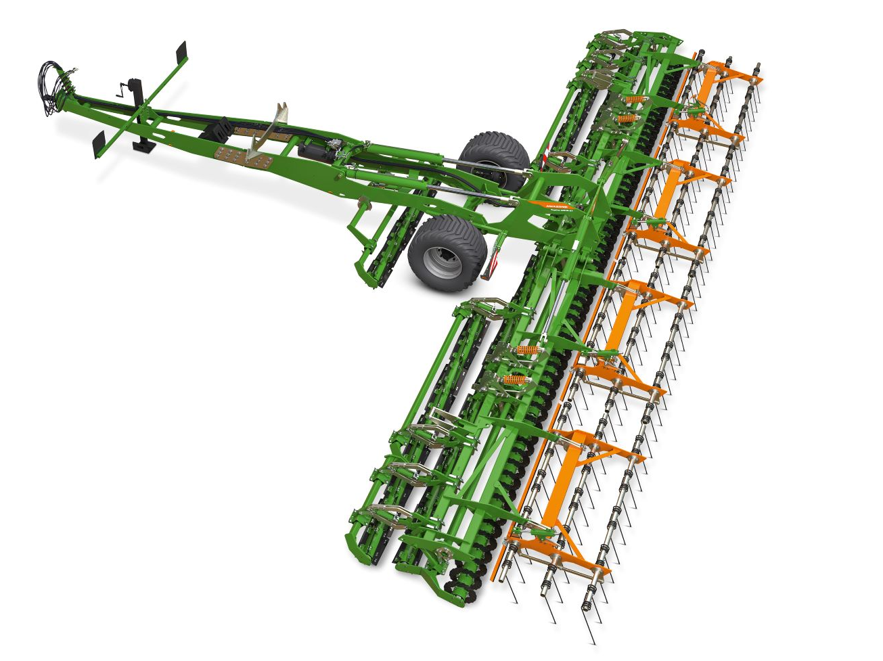

The TopCut concept: ultra-shallow working with a great degree of flexibility.

For the intensive shredding of long plant residues, such as rapeseed stalks, sunflower stalks or catch crops, the use of a double-knife roller as the main tool is ideal. The knife rollers intensively shred and bruise the plant residues, significantly accelerating the decomposition process. In addition, despite the shallow cultivation of 0-2 cm, the knife rollers produce enough fine soil for optimum seedbed generation and so encourage weed seeds and volunteer cereals to germinate. The double-knife roller can also be used for seedbed preparation and generating a stale seedbed. The high circumferential speed produces a very good crumbling effect.
For an even more intensive action, a combination of knife roller and Minimum TillDisc wavey discs can be used as the main tool. This arrangement offers the advantage that the knife roller cuts crosswise and the Minimum TillDisc cuts lengthwise to the direction of travel. This enables cross-cutting, resulting in an intensive shredding action, especially useful in lodged cereals and maize stubble.
A third option is to equip the main tool segment with a double Minimum TillDisc. This combination makes it possible to cut into the ground to a depth of up to 3 cm without moving any soil. Especially in the spring, this has the advantage of opening up the soil, thus promoting improved aeration and quicker soil warming. This is particularly interesting for direct seeding of spring crops such as cereals or beet. The Minimum TillDisc disc element intensively cuts any lodged cereal residues without moving the soil to any great extent.
As an option, the knife roller can be selected as an additional leading tool. This intensifies the shredding of plant residues.

Harrowing or reconsolidation
As an option, and to further improve straw distribution after the combine, the heavy three-row harrow can be used behind the main tools. In addition to distributing the straw, on the one hand, it shakes the seeds out of the straw, seed pods or ears, plus, on the other hand, the harrow produces additional fine soil. This again favours the emergence of weeds. The aggressiveness of the harrow can be altered hydraulically from the cab whilst on the move. As an option, the straw harrow is available as a HD version with carbide tips, thus extending the service life many times over.
As an alternative, packer rollers are available to reduce the drying out of the soil by optimising the reconsolidation. The DW disc roller, with its diameter of 600 mm, is characterised both by its good reconsolidation action and its particularly good cutting effect. Plant residues, such as maize stubble or catch crops, are split more thoroughly and cut up by the sharp rings on the roller. This also promotes faster decomposition. The wedge ring roller, with a KWM 600 matrix tyre profile, produces a particularly good crumbling effect for use in a classic seedbed preparation situation. It is also ideal for creating a stale seedbed. This causes problem weeds, such as black grass and loose silky bent, to germinate before the actual sowing date meaning that they can be controlled mechanically with the TopCut in a second pass.

Conclusion:
The TopCut 12000-2T cutting roller combination is the right choice for every farm, thanks to the large range of tool combinations and following elements. This means that the TopCut can be integrated effectively in classic mulch sowing, sowing after the plough or direct seeding. Thanks to its wide working width of 12.1 m and high working speeds of up to 20 km/h, enormous daily work rates are possible, and this is particularly favourable economically, having a very low fuel consumption of approx. 2.5 l/ha. In addition to the high areas covered, the TopCut also impresses with its resistance to wear and tear. Thanks to the reversible knives on the knife roller, not only can the service life be doubled, but the wear costs can also be minimised.

The advantages at a glance:
- Perfect shredding in rape, sunflowers, maize stubbles and in catch crops
- Optimum shredding for an accelerated decomposition process
- Ultra-shallow soil tillage with high proportion of fine soil for perfect germination conditions, even on cereal stubble
- Improved straw distribution and fine soil generation with the harrow
- Optimum reconsolidation with the packer roller for guaranteed emergence
- Markedly reduced soil moisture loss in comparison to other systems
- Very high work rates with low fuel consumption
- Reduced wear costs due to the reversible blades => double the service life

Plus you can also get an impression of how the TopCut functions in work from our video. You are welcome to share this video in your media outlets.



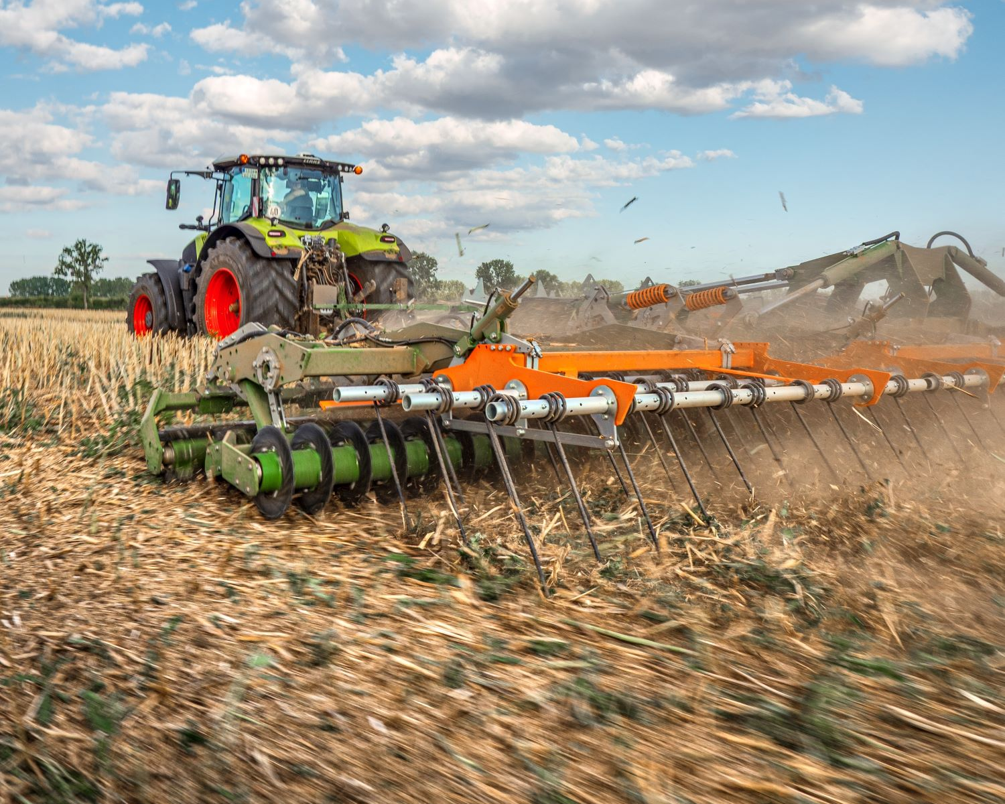
The rape stubble is intensively shredded by the 3 rows of tools and the volunteer rape is mixed with soil right on the surface

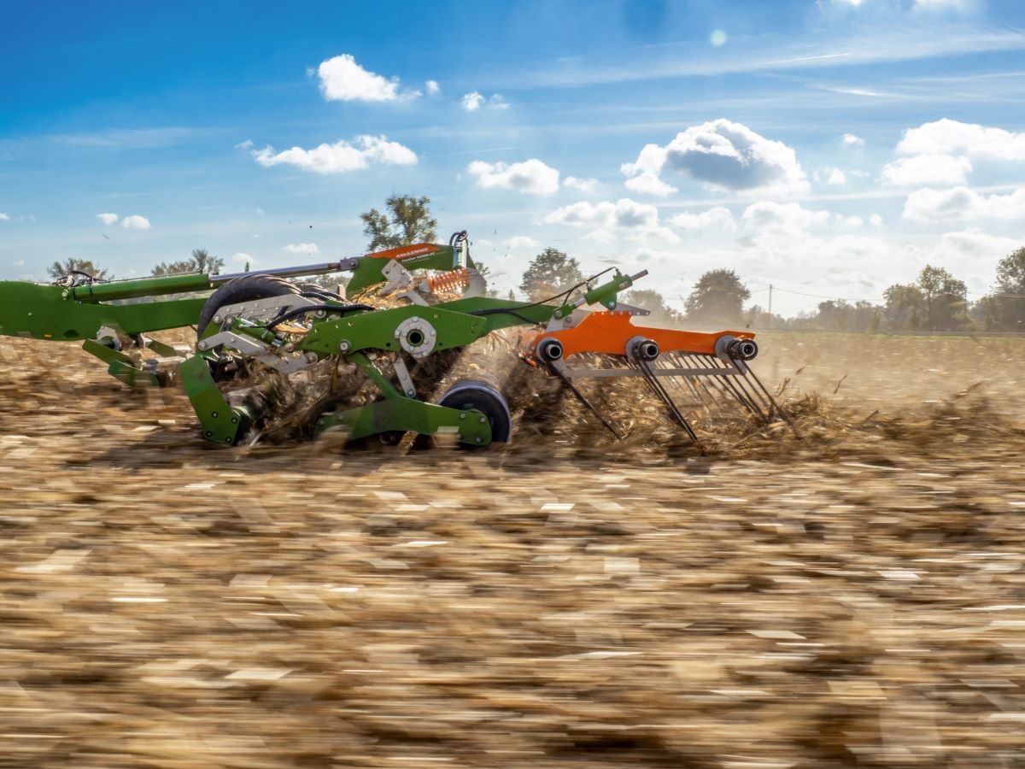
The three tool rows can be customised individually

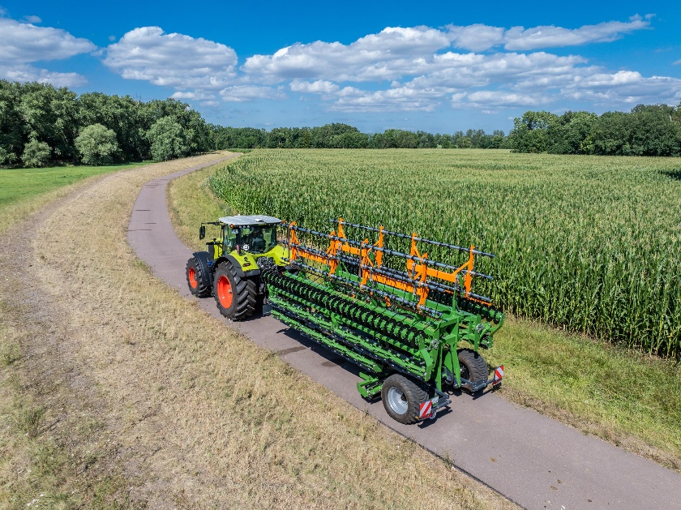

The 12 m TopCut can be folded in to a transport width of 3 m for road transport

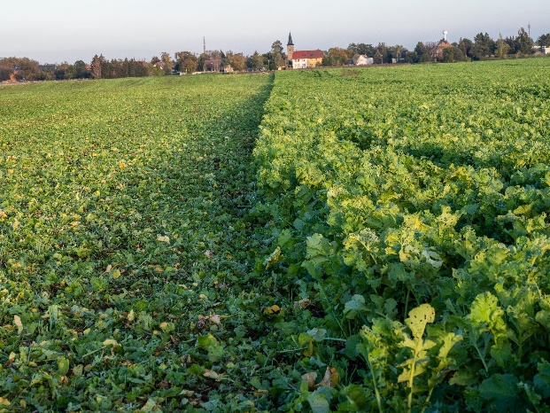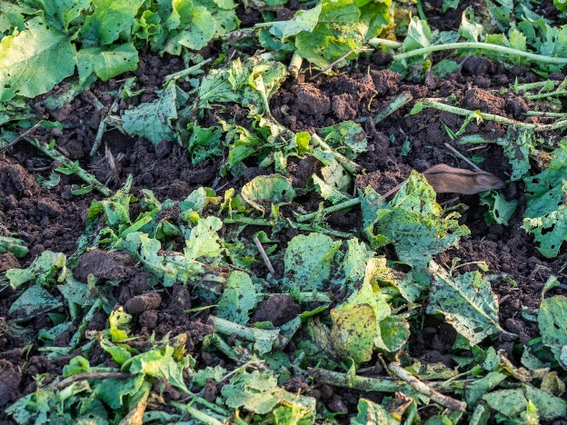
The double-bladed knife roller enables intensive shredding of catch crops.

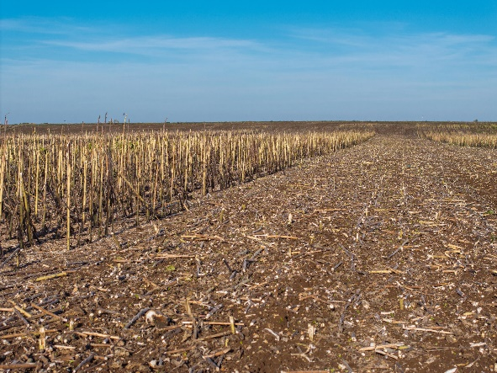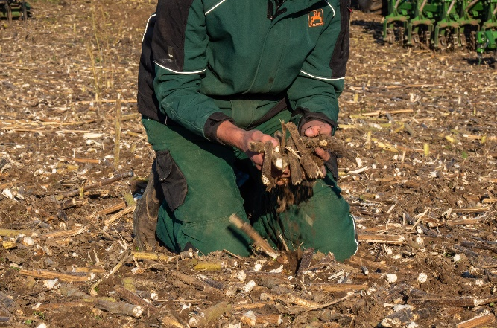
The intensive shredding of sunflower stubbles by the TopCut makes for reliable direct seeding when sowing with tines.

Illustrations, content and technical data are not binding and may differ depending on the level of equipment. Country-specific road traffic regulations apply and must be complied with, meaning that special approval may be required. The permissible axle loads and total weights of the tractor should be checked. Not all the listed combination options are possible with all tractor manufacturers.

About AMAZONE
AMAZONEN-WERKE H. DREYER SE & Co. KG is based in Hasbergen-Gaste in Germany and manufactures agricultural and groundcare machinery. The owner-managed company employs more than 2500 people at nine different production sites. The agricultural machinery range includes soil tillage implements, seed drills, fertiliser spreaders, plant protection equipment and hoes. Based on these core competencies, AMAZONE is now the specialist for intelligent crop production in agriculture.
Further information: https://amazone.net


